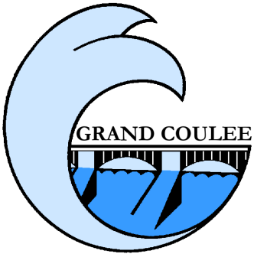
2022 Water Quality Report
Grand Coulee City Water PWS ID# 28700F
(January 1 – December 31, 2022)
__________________________________________________________
The City of Grand Coulee is pleased to provide you with its annual water quality report. This report is a requirement of the United States Environmental Protection Agency and the Washington State Department of Health.
This annual report is designed to inform our customers about the quality of the water we provide. Our goal is to provide you with a safe and dependable supply of drinking water. We are committed to ensuring the quality of your water and protecting our water resources. This report presents our efforts to safeguard our water quality and enlighten our customers on the water we drink.
For more information or questions about this report, please contact Water System Operator Gareth Abbott at: (509) 633-2503, or attend any of our regularly scheduled council meetings. They are held on the third Tuesday of every month at 6:00 pm in the Grand Coulee City Hall.
- Who Watches Your Water?
- U.S. Environmental Protection Agency sets national standards for over one hundred potential drinking water contaminates under the Safe Drinking Water Act.
- The Washington State Department of Health enforces the USEPA standards.
- The City of Grand Coulee has water samples tested in compliance with all state and federal regulations.
- State Certified laboratories are used to test your water according to standards.

In order to insure that tap water is safe to drink, the Department of Health and EPA prescribe regulations that limit the number of certain contaminants in the water provided by public water systems. The food and Drug Administration (FDA) and the Washington Department of Agriculture regulations establish limits for contaminants in bottled water that must provide the same protection for public health.

- About Your Health
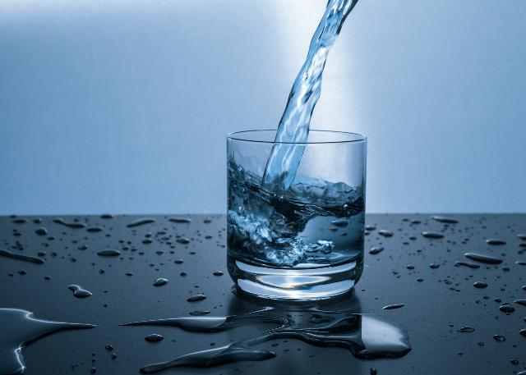
The sources of drinking water (both tap water and bottled water) include rivers, lakes, streams, ponds, reservoirs, springs and wells. As water travels over the land surface or through the ground it dissolves naturally-occurring minerals and can pick up substances resulting from the presence of animals or human activity.
All drinking water, including bottled water, may reasonably be expected to contain at least small amounts of some contaminants. The presence of contaminants does not necessarily indicate that the water poses a health risk. A contaminant is defined as any substance in water. Not all substances are harmful. More information about contaminants and potential health effects can be obtained by calling the Environmental Protection Agency’s Safe Drinking Water Hotline at 1(800) 426-4791 or from the EPA’s Office of Ground Water website at: www.epa.gov/OGWDW
Inadequately treated water may contain disease-causing organisms, such as bacteria, viruses and parasites, which can cause symptoms such as nausea, cramps, diarrhea, and associated headaches.
Some people may be more vulnerable to contaminates in drinking water than the general population. Immuno-compromised persons, such as persons undergoing chemotherapy, persons who have undergone organ transplants, people with HIV/AIDS, or other immune system disorders, some elderly, and infants can be particularly at risk from infections. These people should seek advice about drinking water by contacting their health care provider. EPA/CDC guidelines to lessen the risk of infection by microbiological contaminants are available from the Safe Drinking Water Hotline. 1(800) 426-4791
- Monitoring Results for Year 2022
Our current water source is ground water from 3-wells located and pumped from the Electric City Water System, Source ID 22850H. The City of Grand Coulee routinely monitors this water for constituents according to Federal and State laws. Our water is treated by means of tablet chlorine disinfection at the point where it enters the Grand Coulee distribution system. To insure that a detectable concentration is active in all parts of the distribution system (minimum total free chlorine residual of 0.2mg/l), samples are taken at strategic locations throughout the City. Typical disinfection residuals are in the 0.3 - 0.7 mg/l range. This information along with other data is compiled monthly in a Chlorination Report and submitted to the Department of Health.
The City is required to collect monthly water samples to test for the presence of e.coli and fecal coliform. During 2022, routine coliform samples all tested satisfactory. There were no public health concerns.
Total Coliform: The Total Coliform Rule requires water systems to meet a stricter limit for coliform bacteria. Coliform bacteria are usually harmless, but their presence in water can be an indication of disease-causing bacteria. When coliform bacteria are found, special follow-up tests are done to determine if harmful bacteria are present in the water supply. If this limit is exceeded, the water supplier must notify the public by newspaper, television or radio.
The following table shows the results of our monitoring for the period of January 1 to December 31, 2022. All drinking water, including bottled drinking water, may be reasonably expected to contain at least small amounts of some constituents. It’s important to remember that the presence of these constituents does not necessarily pose a health risk. More information about contaminants and potential health effects can be obtained by calling the Environmental Protection Agency’s Safe Drinking Water Hotline 1(800) 426-4791.
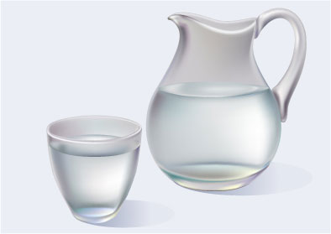
- List of Abbreviations
- (MCL) Maximum Contaminant Level
- (MCLG) Maximum Contaminant Level Goal
- (AL) Action Level (triggers treatment or other)
- (ND) Non Detectable
- (NA) Not Applicable
- (NTU) Nephelometric Turbidity Units (A measurement of the clarity of water)
- (ppb) Parts Per Billion
- (ppt) Parts Per Trillion
- (MFL) Million Fibers per Liter
- (mg/L) milligrams per liter
- (ug/L) micrograms per liter
- (MRDLG) Maximum Residual Disinfectant Level Goal
- (MRDL) Maximum Residual Disinfectant Level
Action Level - The concentration of a contaminant which, if exceeded, triggers treatment or other requirements, which a water system must follow.
Treatment Technique (TT) - A treatment technique is a required process intended to reduce the level of a contaminant in drinking water.
Maximum Contaminant (or Residual Disinfectant) Level - The "Maximum Allowed" (MCL) is the highest level of a contaminant that is allowed in drinking water. MCLs are set as close to the MCLGs as feasible using the best available treatment technology.
Maximum Contaminant (or Residual Disinfectant) Level Goal - The "Goal"(MCLG) is the level of a contaminant in drinking water below which there is no known or expected risk to health. MCLGs allow for a margin of safety.
MCL's are set at very stringent levels. To understand the possible health effects described for many regulated constituents, a person would have to drink 2 liters of water every day at the MCL level for a lifetime to have a one-in a-million chance of having a related health effect.

- Water Testing Results
Contaminant | Compliance | Results | Units | MCLG | MCL | Sample Date | Contamination sources
Microbiological Contaminants
Turbidity | Yes | .01 | NTU | n/a | TT | 2019 | Soil runoff
Inorganic Contaminants
Antimony | Yes | ND | mg/l | 0.006 | 0.006 | 2015 | Petroleum, fire retardants, ceramics, solder
Arsenic | Yes | 3.4 | ppb | 0 | 10 | 2022 | Natural deposits; runoff from orchards; glass & electronics production
Asbestos | Yes | 0.1130 | MFL | 7 | 7 | 2015 | Natural deposits; degradation of piping
Barium | Yes | 0.0144 | mg/l | 2 | 2 | 2015 | Natural deposits; metal refining
Beryllium | Yes | ND | mg/l | 0.004 | 0.004 | 2015 | Metal refining; coal burning
Cadmium | Yes | ND | mg/l | 0.005 | 0.005 | 2015 | Natural deposits; corrosion of galvanized pipes; batteries; paints.
Chromium | Yes | ND | mg/l | 100 | 100 | 2015 | Natural deposits; steel & pulp mills.
Cyanide | Yes | 5 | mg/l | 200 | 200 | 2015 | Steel or fertilizer factory discharge.
Fluoride | Yes | 0.576 | mg/l | 2 | 4 | 2015 | Natural deposits; water additive; fertilizer & aluminum factories.
Mercury (inorganic) | Yes | ND | mg/l | 0.002 | 0.002 | 2015 | Natural deposits; factory discharge; landfill runoff; cropland runoff.
Nitrate (as Nitrogen) | Yes | 9.70 | mg/l | 10 | 10 | 2022 | Natural deposits; leaching of sewage; runoff from fertilizer use.
Selenium | Yes | 0.00117 | mg/l | 5 | 10 | 2015 | Natural deposits; discharge from refineries & mines.
Thallium | Yes | ND | mg/l | 0.002 | 0.005 | 2015 | Discharge from electronics, glass & drug factories; ore processing.
Disinfection Residual
Chlorine Dioxide (ClO2) | Yes | .56 | mg/L | 0.8 | 2 | 2022 | Used in arsenic removal process, although not required to monitor as a disinfectant.
Disinfection Byproducts
TTHMs | Yes | ND | mg/L | n/a | .008 | 2022 | Byproduct of arsenic removal process.
HAA5 | Yes | ND | mg/L | n/a | .006 | 2022 | Byproduct of arsenic removal process.
Contaminant | Compliance | AL | Water 90th % | MCLG | Samples Exceeding AL | Sample Date | Contamination sources
Lead | Yes | 0.015 | 0.000560 | 0 | 0 of 10 samples taken | 2022 | Corrosion of plumbing
Copper | Yes | 1.3 | 0.0293 | 0.157 | 0 of 10 samples taken | 2022 | Corrosion of plumbing

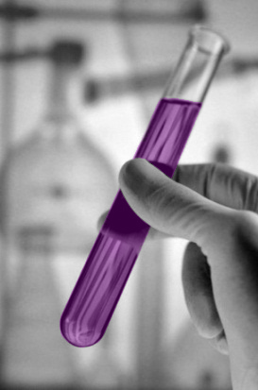
Some people who drink water that contains arsenic in excess of the MCL over many years could experience skin damage or problems with their circulatory system, and may have an increased risk of getting cancer. Most types of cancer and circulatory disease are due to factors other than exposure to arsenic. EPA’s standard balances the current understanding of arsenic’s health effects against the costs of removing arsenic from drinking water.
Elevated levels of lead in drinking water can cause serious health problems, especially for pregnant women and young children. Lead in our drinking water primarily comes from components and materials used in household plumbing. If your water has been sitting for several hours, you can minimize the risk for lead exposure by flushing water through the tap for 1-2 minutes before using water for cooking or drinking.
WATER SAVING TIPS:
- Fix leaks promptly, little drips can waste lots of water.
- Replace your showerhead with a low flow model.
- Turn off the faucet while brushing teeth or shaving.
- Keep drinking water in your refrigerator, running tap water until it is cold wastes water.
- Wash only full loads in the dishwasher and washing machine.
- De-thatch and aerate lawns for better water absorption. Clip lawns no shorter than 2 inches.
- Leave the grass clippings on the lawn. They are 90% water and provide nitrogen.
- Water in morning hours, before 10:00 a.m. to avoid excessive evaporation and prevent mold.
- Adjust sprinklers so you are watering only what grows, not the street or sidewalk.

